REPORT

Writer  Samyn Caroline | Date  22 March 2012 | Ref  RBE0372.doc
Subject:
- DLL (Win32) developed with Visual C++ 6 (“not managed” code) used in a C# application developed with Visual Studio .NET (“managed” code)

Files:

TABLE OF CONTENTS

1. Introduction 3
2. How to use a DLL developed with Visual C++ 6 4
2.1. C++ Application (Visual C++ 6) 4
2.2. C# Application (Visual Studio .NET 2010) 4
3. How to compile the VC++ 6 sources of a DLL 5
3.1. Visual C++ 6 5
3.2. Visual Studio .NET 2010 5
4. Synthesis 8
5. Conclusion and remarks 9

Introduction
The reports describes how to use a DLL (Win32) developed with Visual C++ 6 (“not managed” code) used in a C# application developed with Visual Studio .NET (“managed” code).

How to use a DLL developed with Visual C++ 6

C++ Application (Visual C++ 6)

No managed code
DLL 32bits
(VC++ 6)
Application 32bits
(VC++ 6)
Header file (.h)
Library file (.lib)
Windows 7
32bits
OK

C# Application (Visual Studio .NET 2010)
No managed code
Managed code
DLL 32bits
(VC++ 6)
DLL 32bits
(VS2010)
Application C#
32bits
(VS2010)
“PInvoke” C# Interface (.cs)
(VS2010)

(Win32 project)
Windows 7
32bits
Windows 7
64bits
Application C#
64bits
(VS2010)
OK
Exception

“PInvoke” C# Interface (.cs)
(VS2010)

Application C#
32bits
(VS2010)
Windows 7
32bits
Windows 7
64bits
Application C#
64bits
(VS2010)
Exception
Exception

How to compile the VC++ 6 sources of a DLL

Visual C++ 6
In Visual C++ 6, create a new project to build a DLL.
Import all sources files and compile this new project.

Visual Studio .NET 2010
In Visual Studio 2012, add a new “Win32” project from “Visual C++”.

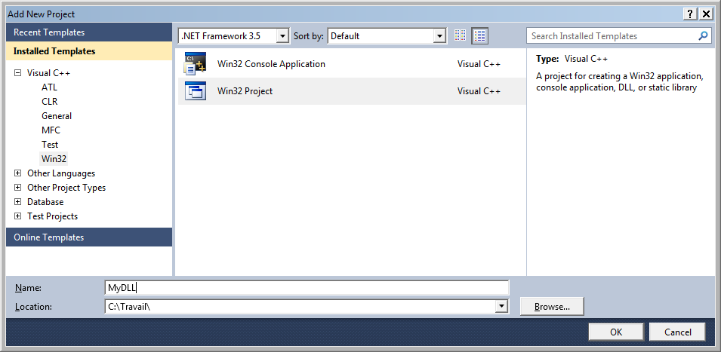

Next, a dialog box appears, select “Next”.

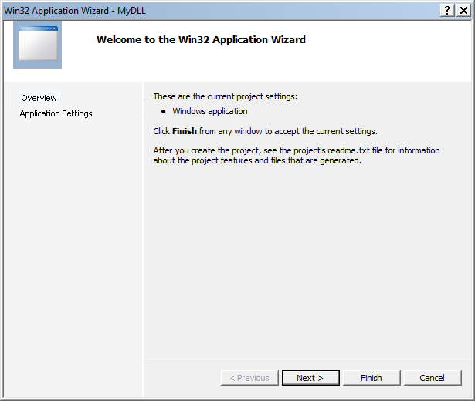

Now, in the following view, select “DLL” application type and “Empty project” additional option.

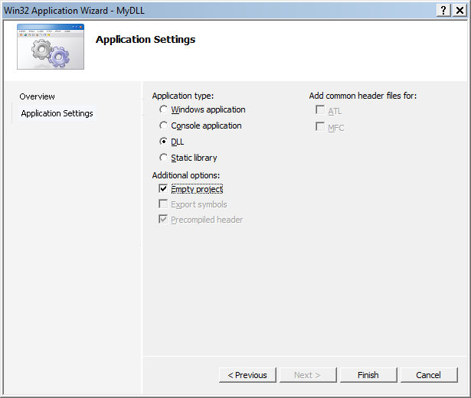

Click on “Finish” to create the project.
After, copy all DLL sources files in the project folder.

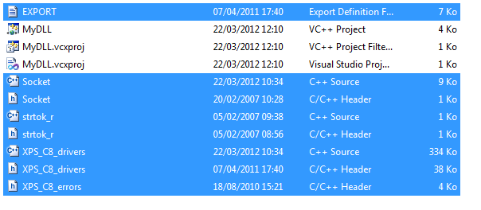
Once all files are copied, add these files in the project with “Add” => “Existing Item” context menu.

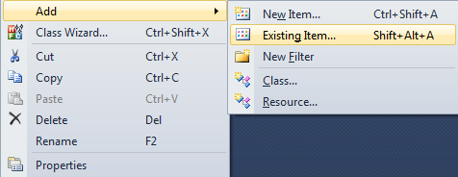

Open the project properties and select “Code Generation” from “C/C++” menu.
Modify the “RuntimeLibrary” to “Multi-threaded (/MT)”.
Click on OK to apply.

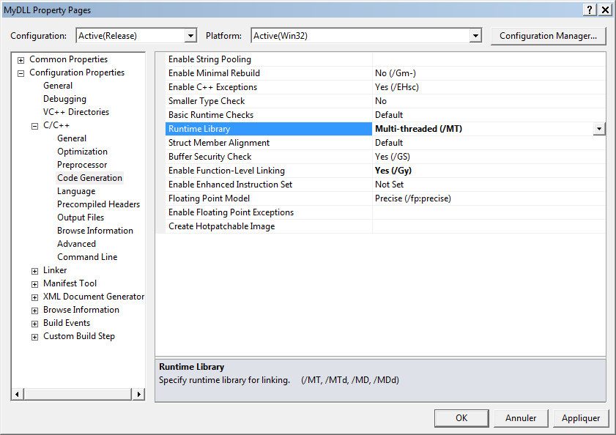

Now, you can compile the project.
Some warnings are detected but the DLL is built.

Synthesis

 | DLL VC++ 6  (32bits) | DLL VS2010  (32bits)
Application .NET 32bits | OK | Exception (*)
Application .NET 64bits | Exception (**) | Exception (**)

(*) Exception code: 0xC0000005
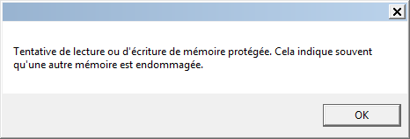

(**) 64 bit exe tried to load a 32bit DLL
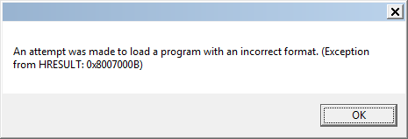

Conclusion and remarks

Comments:

Conclusion:

The DLL 32bits developed with Visual C++ 6.0 can be used in an application .NET 32bits developed with Visual Studio 2010. It’s possible with a “PInvoke” interface.

